Ansible Roles
Ansible Roles are the primary mechanism for breaking a monolithic Playbook into multiple files. This simplifies writing complex playbooks and makes them easier to reuse.
Think of a Playbook as a script where you write everything in one file, and a Role as a "Class" or "Package" in programming. A Role allows you to bundle automation content (tasks, variables, files, templates, and handlers) into a standardized directory structure.
Why Use Roles?
- Modularity: Break large, complex playbooks into small, manageable chunks.
- Reusability: Write a "MySQL" role once, and use it across 10 different projects.
- Structure: Enforces a standard layout that any Ansible developer can instantly understand.
- Sharing: Roles can be shared via Ansible Galaxy (the public repository for Ansible roles).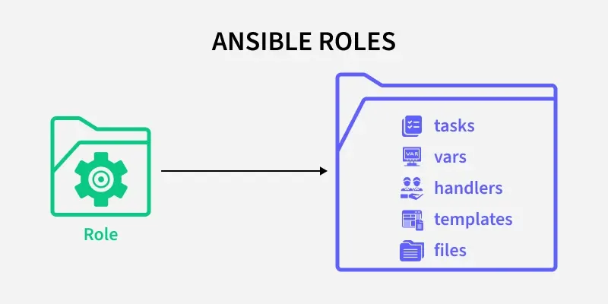
Ansible Role
The magic of Roles lies in their specific directory structure. Ansible looks for a main.yml file in each of these standard directories to know what to do.
To create the skeleton of a role automatically, use the ansible-galaxy command:
ansible-galaxy init my_webserver_role
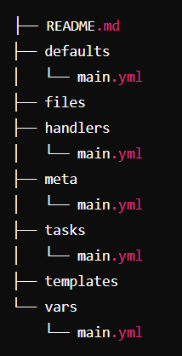
Directory | File Required | Description
tasks/ | main.yml | Contains the main list of tasks to be executed by the role.
handlers | main.yml | Contains handlers, which are tasks triggered by other tasks (e.g., "Restart Service").
defaults/ | main.yml | Low-priority variables. These act as "default settings" that users can easily override in their playbooks.
vars/ | main.yml | High-priority variables. Variables defined here are difficult to override. Use this for constants internal to the role.
files/ | (Files) | Contains static files (scripts, configs, certs) that need to be copied to the remote machine via the copy module.
templates/ | *.j2 | Contains Jinja2 templates. These are dynamic files where variables are replaced before being copied (e.g., nginx.conf.j2).
meta/ | main.yml | Metadata about the role (author, license) and dependencies (other roles that must run before this one).
tests/ | inventory, test.yml | Scripts to test the role (often used with CI tools like Molecule).
Steps to use Ansible Role
Implementing Ansible Roles involves several steps, which are outlined below:
Step 1 - Create the Role Directory Structure: Ansible provides a command to create a role's directory structure.
ansible-galaxy init <role_name>
Role created
- This command creates a directory structure with subdirectories for tasks, handlers, files, templates, vars, defaults, and meta.
Step 2 - Define Tasks: The main logic of the role is defined in the `tasks` directory. Create a `main.yml` file within this directory to list all tasks.
# roles/<role_name>/tasks/main.yml
---
- name: Install Nginx
apt:
name: nginx
state: present
Step 3 - Add Handlers: If there are services that need to be restarted or actions triggered by changes, define them in the `handlers` directory.
# roles/<role_name>/handlers/main.yml
---
- name: Restart Nginx
service:
name: nginx
state: restarted
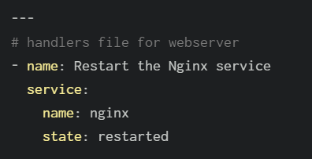
Step 4 - Provide Default and Variable Values: Use the `defaults` and `vars` directories to set default values and other variables required by the role.
# roles/<role_name>/defaults/main.yml
---
nginx_version: latest
# roles/<role_name>/vars/main.yml
---
some_variable: value
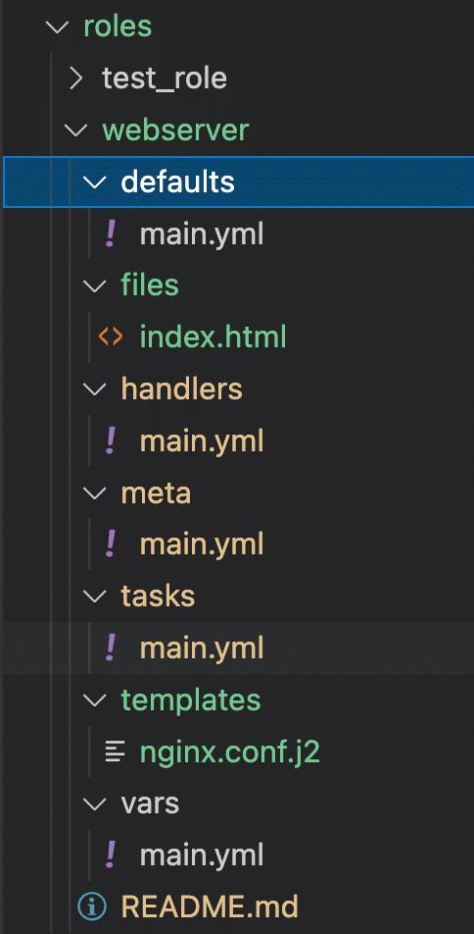
Step 5 - Templates and Files: Place configuration templates and static files in the `templates` and `files` directories, respectively.
# roles/<role_name>/templates/nginx.conf.j2
server {
listen 80;
server_name {{ server_name }};
...
}
Step 6 - Metadata and Dependencies: Define any role dependencies in the `meta` directory.
# roles/<role_name>/meta/main.yml
---
dependencies:
- { role: another_role }
Step 7 - Include Roles in Playbooks: Finally, include the role in your playbook.
# playbook.yml
---
- hosts: webservers
roles:
- role_name
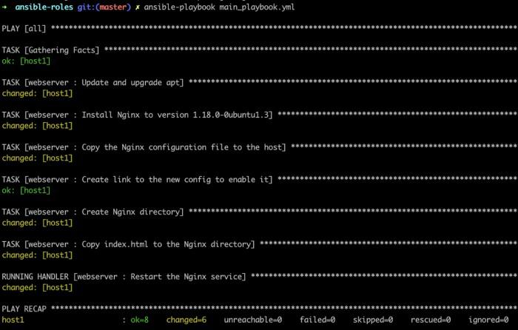
Use Cases of Ansible Role
Ansible Roles are used in a variety of contexts, including:
- Infrastructure as Code (IaC): Managing and provisioning infrastructure in a consistent and repeatable manner.
- Application Deployment: Deploying applications with all necessary dependencies and configurations.
- Configuration Management: Ensuring systems are configured correctly and consistently across environments.
- Continuous Integration/Continuous Deployment (CI/CD): Integrating with CI/CD pipelines to automate the deployment process.

Best Practices for Roles
- Keep it Focused: A role should do one thing well. Don't make a "webserver_and_database_and_cache" role. Split them into nginx, mysql, and redis roles.
- Use Defaults, Not Vars: Always prefer defining variables in defaults/main.yml rather than vars/main.yml. This allows users of your role to override settings easily in their playbooks without fighting precedence rules.
- Name Things Clearly: Use descriptive names for your tasks. This makes the output log readable.
- Idempotency is King: Ensure every task in your role is idempotent (can be run multiple times without side effects).
You have successfully created your first Ansible role. Here's what each step did:
Step | Command | What it did
1 | ls | Listed the folders in your home directory. You had ansible and ansible_roles.
2 | cd ansible | Entered your Ansible project directory.
3 | ls | Verified the project contains inventory.ini, playbook.yml, and nginx_version_playbook.yml.
4 | mkdir roles | Created a roles directory to store Ansible roles.
5 | ls | Confirmed the roles directory was created.
6 | cd roles | Entered the roles directory.
7 | ansible-galaxy init my_custom_roles | Used Ansible Galaxy to generate a new role named my_custom_roles with the standard directory structure.
8 | ls | Verified that the my_custom_roles role was created.
9 | cd my_custom_roles | Entered the newly created role.
10 | ls | Viewed the standard role folders created automatically (tasks, handlers, defaults, vars, etc.).
11 | cd tasks | Entered the tasks directory, where the role's main tasks are defined.
12 | ls | Confirmed that main.yml exists. This is the main task file for the role.
Role structure created
ansible/
├── inventory.ini
├── playbook.yml
├── nginx_version_playbook.yml
└── roles/
└── my_custom_roles/
├── defaults/
├── files/
├── handlers/
├── meta/
├── tasks/
│ └── main.yml
├── templates/
├── tests/
├── vars/
└── README.md
What each folder is for
- tasks/ → Contains the tasks that the role executes (main.yml).
- handlers/ → Contains handlers, such as restarting a service.
- defaults/ → Stores default variables that users can override.
- vars/ → Stores role-specific variables with higher precedence.
- files/ → Holds static files to copy to target servers.
- templates/ → Holds Jinja2 template (.j2) files.
- meta/ → Stores role metadata and dependencies.
- tests/ → Contains test inventory and playbooks.
- README.md → Documentation for the role.
Since you're learning Ansible, here's a complete step-by-step lab to manage both your old Nginx servers and a new Apache server.
Architecture
Ansible Server
|
---------------------------------
| | |
Nginx Server 1 Nginx Server 2 Apache Server
- Old EC2-1 → Nginx
- Old EC2-2 → Nginx
- New EC2 → Apache

Step 1: Launch a New EC2 Instance
- Launch a new Ubuntu EC2 instance.
- Allow:
  - SSH (22)
  - HTTP (80)
- Use the same key pair.

Step 2: Copy the SSH Public Key
On the Ansible server:
cat ~/.ssh/id_ed25519.pub
Copy the output.
On the new EC2:
mkdir -p ~/.ssh
nano ~/.ssh/authorized_keys
Paste the key.
Save:
- Ctrl + O
- Enter
- Ctrl + X
Set permissions:
chmod 700 ~/.ssh
chmod 600 ~/.ssh/authorized_keys

Step 3: Test SSH
From the Ansible server:
ssh ubuntu@<NEW_PUBLIC_IP>
You should log in without a password.

Step 4: Update Inventory
Go to your project.
cd ~/ansible
Edit inventory.
vim inventory.ini
Add:
[nginx]
13.127.255.199
13.235.114.61

[apache]
<NEW_PUBLIC_IP>

[all_servers:children]
nginx
apache
Save.

Step 5: Check Inventory
cat inventory.ini
Expected:
[nginx]
13.127.255.199
13.235.114.61

[apache]
<NEW_PUBLIC_IP>

[all_servers:children]
nginx
apache

Step 6: Test Connectivity
Nginx servers:
ansible -i inventory.ini nginx -m ping
Apache server:
ansible -i inventory.ini apache -m ping
All servers:
ansible -i inventory.ini all_servers -m ping
All should return:
SUCCESS

Step 7: Create Apache Role
Go to roles.
cd ~/ansible/roles
Create role.
ansible-galaxy init apache_role

Step 8: Edit Task File
vim ~/ansible/roles/apache_role/tasks/main.yml
Paste:
---
- name: Install Apache
ansible.builtin.apt:
name: apache2
state: present
update_cache: yes

- name: Start Apache
ansible.builtin.service:
name: apache2
state: started
enabled: yes
Save.

Step 9: Create Apache Playbook
Go back.
cd ~/ansible
Create playbook.
touch apache_site.yml
Edit:
vim apache_site.yml
Paste:
---
- name: Configure Apache Server
hosts: apache
become: yes

roles:
- apache_role
Save.

Step 10: Run Apache Playbook
ansible-playbook -i inventory.ini apache_site.yml
Expected:
TASK [Gathering Facts]
ok

TASK [Install Apache]
changed

TASK [Start Apache]
changed

PLAY RECAP
failed=0

Step 11: Verify Apache
Open:
http://<NEW_PUBLIC_IP>
You should see the Apache2 Ubuntu Default Page.

Step 12: Create Nginx Role
cd ~/ansible/roles
Create:
ansible-galaxy init nginx_role

Step 13: Edit Nginx Tasks
vim ~/ansible/roles/nginx_role/tasks/main.yml
Paste:
---
- name: Install Nginx
ansible.builtin.apt:
name: nginx
state: present
update_cache: yes

- name: Start Nginx
ansible.builtin.service:
name: nginx
state: started
enabled: yes
Save.

Step 14: Create Nginx Playbook
touch nginx_site.yml
Edit:
---
- name: Configure Nginx Servers
hosts: nginx
become: yes

roles:
- nginx_role

Step 15: Run Nginx Playbook
ansible-playbook -i inventory.ini nginx_site.yml

Step 16: Verify Nginx
Open:
http://13.127.255.199
and
http://13.235.114.61
You should see the Nginx Welcome Page.

Final Project Structure
ansible/
├── inventory.ini
├── apache_site.yml
├── nginx_site.yml
├── roles/
│ ├── apache_role/
│ │ ├── tasks/
│ │ │ └── main.yml
│ │ ├── handlers/
│ │ ├── defaults/
│ │ ├── vars/
│ │ ├── files/
│ │ ├── templates/
│ │ ├── meta/
│ │ └── README.md
│ └── nginx_role/
│ ├── tasks/
│ │ └── main.yml
│ ├── handlers/
│ ├── defaults/
│ ├── vars/
│ ├── files/
│ ├── templates/
│ ├── meta/
│ └── README.md
This is a clean, real-world Ansible project structure where different server groups are managed with different roles.

